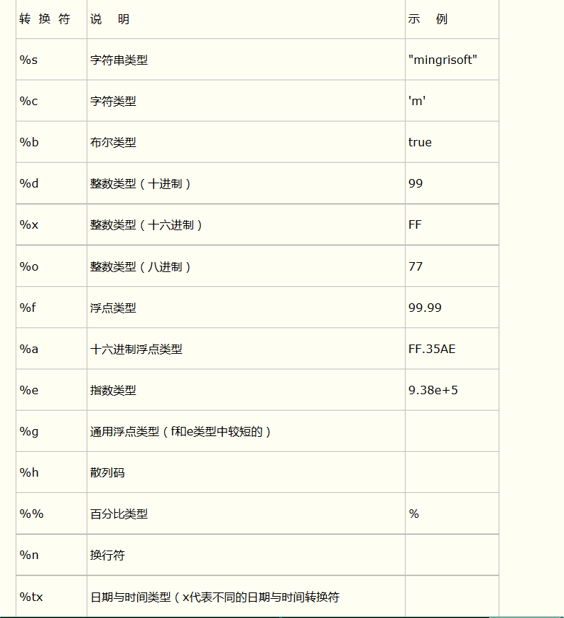

实例

public static void main(String[] args) {

String str=null;

str=String.format("Hi,%s", "王力");

System.out.println(str);

str=String.format("Hi,%s:%s.%s", "王南","王力","王张");

System.out.println(str);

System.out.printf("字母a的大写是：%c %n", 'A');

System.out.printf("3>7的结果是：%b %n", 3>7);

System.out.printf("100的一半是：%d %n", 100/2);

System.out.printf("100的16进制数是：%x %n", 100);

System.out.printf("100的8进制数是：%o %n", 100);

System.out.printf("50元的书打8.5折扣是：%f 元%n", 50\*0.85);

System.out.printf("上面价格的16进制数是：%a %n", 50\*0.85);

System.out.printf("上面价格的指数表示：%e %n", 50\*0.85);

System.out.printf("上面价格的指数和浮点数结果的长度较短的是：%g %n", 50\*0.85);

System.out.printf("上面的折扣是%d%% %n", 85);

System.out.printf("字母A的散列码是：%h %n", 'A');

}